

KGiSL INSTITUTE OF TECHNOLOGY

**Project_Title : COVID-19 CASES**

**Mentor :** Indu Poornima R

**Team Members :**

KARTHIKEYAN B

TINU VARSHAN A S

LOGESH S

MOHAMED YASEEN M

**Project Description :** COVID-19 CASES

**Objective :**

"To analyze and visualize COVID-19 cases data to:

* 1. Identify trends and patterns: Explore the temporal and geographic distribution of cases.
* Assess the impact: Evaluate the severity and progression of the pandemic in specific regions.
* 2. Inform decision-making: Provide insights for public health measures and resource allocation.
* 3. Communicate findings: Create clear and informative
* visualizations to aid in understanding and awareness."

This objective sets a broad overview of what you intend to achieve with your data analysis, which can then be broken down into specific tasks and analyses as you work on the project.

**#Step_1 :**

Mounting the colab with the google drive for attaching the dataset to the program.



**#Step_2 :**

Loading the raw dataset from the drive by mounting it to the colab.

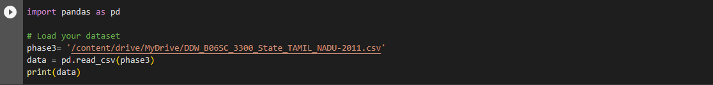

**#Output :**

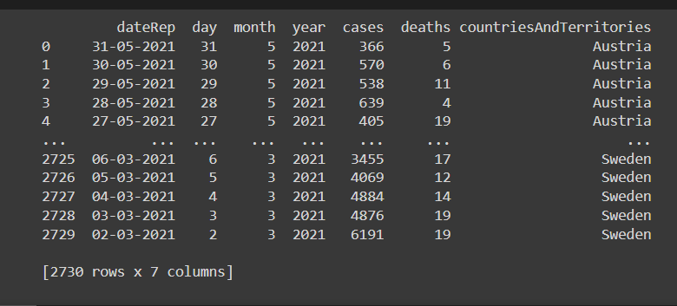

**#Step_3 :**

The step involves the processing of the raw dataset.

**#Processing :**

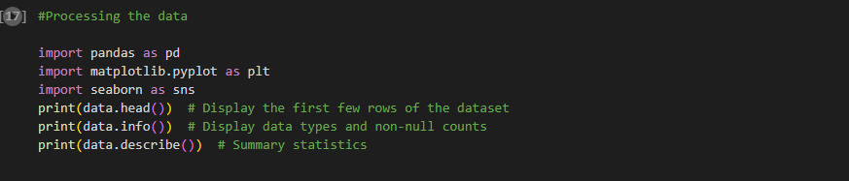

**#Output :**

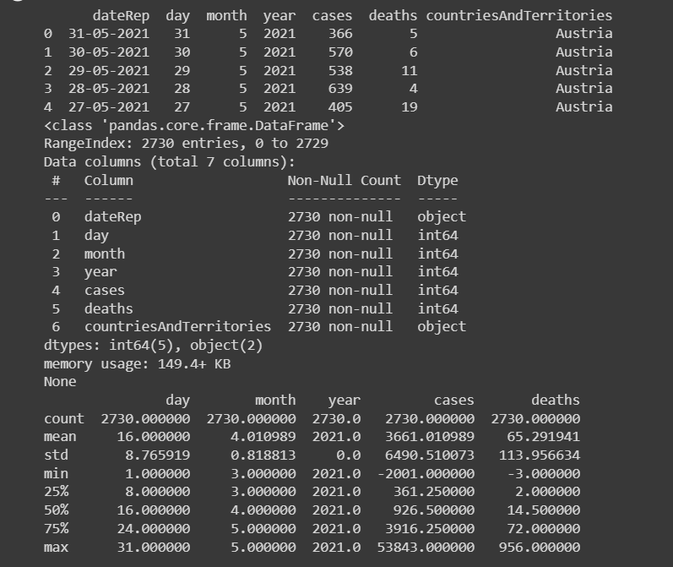

**#Step_4 :**

This step involves the accuracy of the whole dataset.

